Assignment 2 Answers and Explanation
Task2
Suitable IP range for HQ and branch
HQ supports up to 8000 devices and branch supports up to 500 devices.
Private block of 10.10.0.0/16 (IPv4 address)
An IPv4 has 32 bits, so to find host bits:
32 bits - 16 network bits = 16 host bits
To calculate how many usable IP addresses a subnet provides:
Usable hosts = 2^h - 2
2^13 - 2 = 8190 (supports more than 8000 devices for HQ)
2^9 - 2 = 510 (supports more than 500 devices for branch)
To find network bits, subtract from 32 bits:
32 bits - 13 host bits = /19 (HQ)
32 bits - 9 host bits = /23 (branch)
IPv4 has 4 octets (32 bits) so each octet = 8 bits:
/19 takes up 2 octets + 3 bits of 3rd octet = 224
/23 takes up 2 octets + 7 bits of 3rd octet = 254
Hence subnet masks are:
/19 = 255.255.224.0
/23 = 255.255.254.0
To calculate block size:
256 - 224 = 32
256 - 254 = 2
 | HQ Range | Branch Range
Network | 10.10.0.0 | 10.10.32.0
Usable Range | 10.10.0.1 - 10.10.31.254 | 10.10.32.1 - 10.10.33.254
Broadcast | 10.10.31.255 | 10.10.33.255

Network Diagram
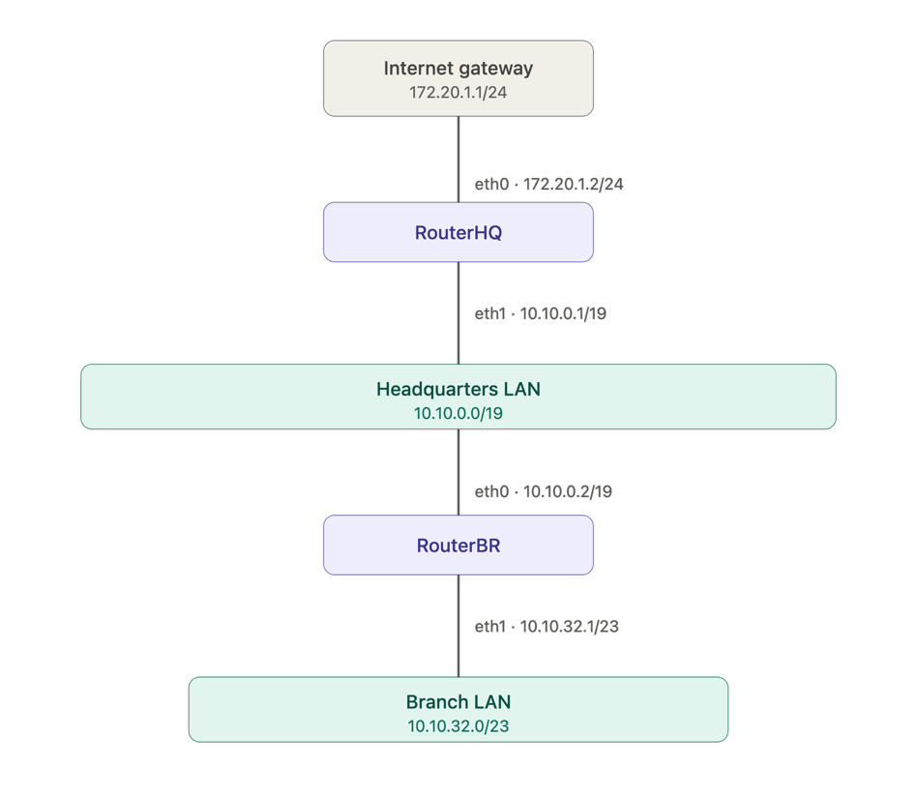

RouterHQ Routing Table
Destination | Gateway | Genmask | Flags | Iface
10.10.0.0 | * | 255.255.224.0 | U | eth1
10.10.32.0 | 10.10.0.2 | 255.255.254.0 | UG | eth1
172.20.1.0 | * | 255.255.255.0 | U | eth0
default | 172.20.1.1 | 0.0.0.0 | UG | eth0

